# CS 255 System Design Document Template

## UML Diagrams

### UML Use Case Diagram

### UML Activity Diagrams

1. Taking an Exam

1. Registration Process

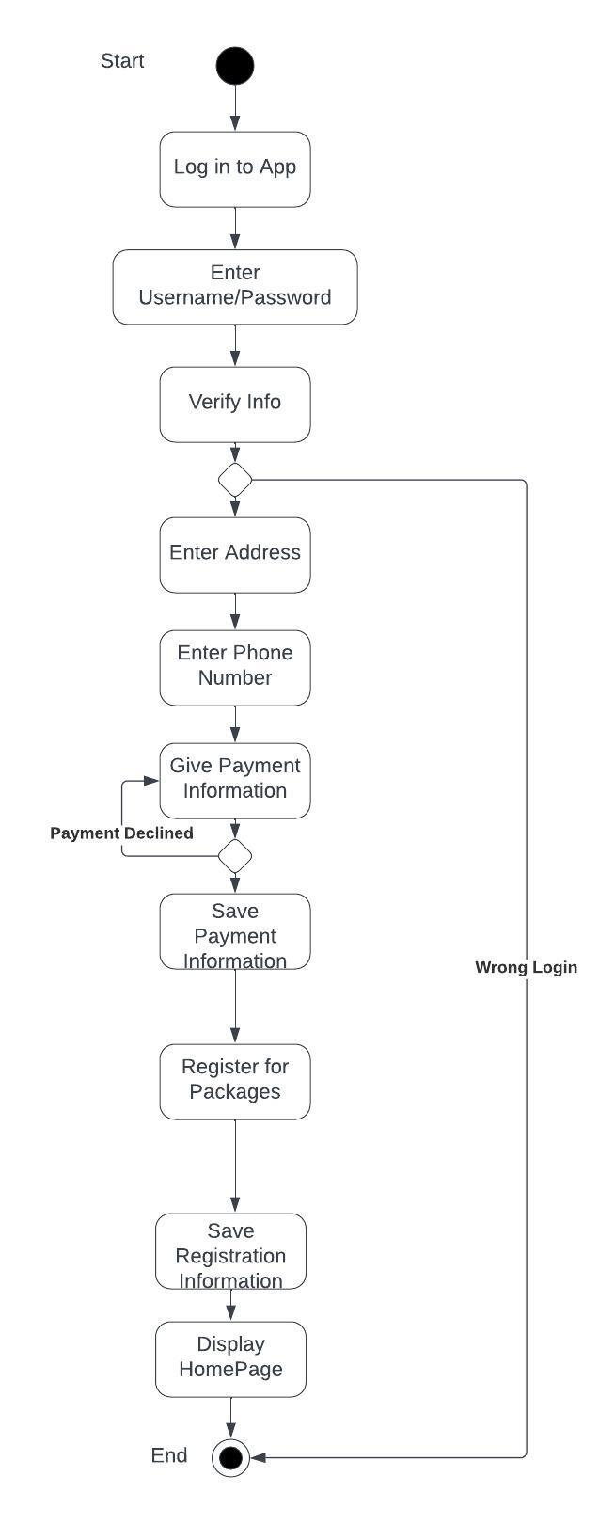

### UML Sequence Diagram

### UML Class Diagram

## Technical Requirements

1. Hardware requirements
   1. There will need to be servers in place to hold data such as customer info and payment info securely. These could be cloud-based or physical.
   2. Computers that can run the software will be required
   3. Internet accessibility through a router
2. Software Requirements
   1. A database management system for info/grades/appointments
   2. Authentication and authorization capabilities
3. Tools
   1. A tool for logging/reporting errors
   2. A payment management application
4. Infrastructure
   1. Firewall protection
   2. Backup systems for data